Engineering Notebook Samples

The following would be considered an excellent example of entries in an engineering notebook.

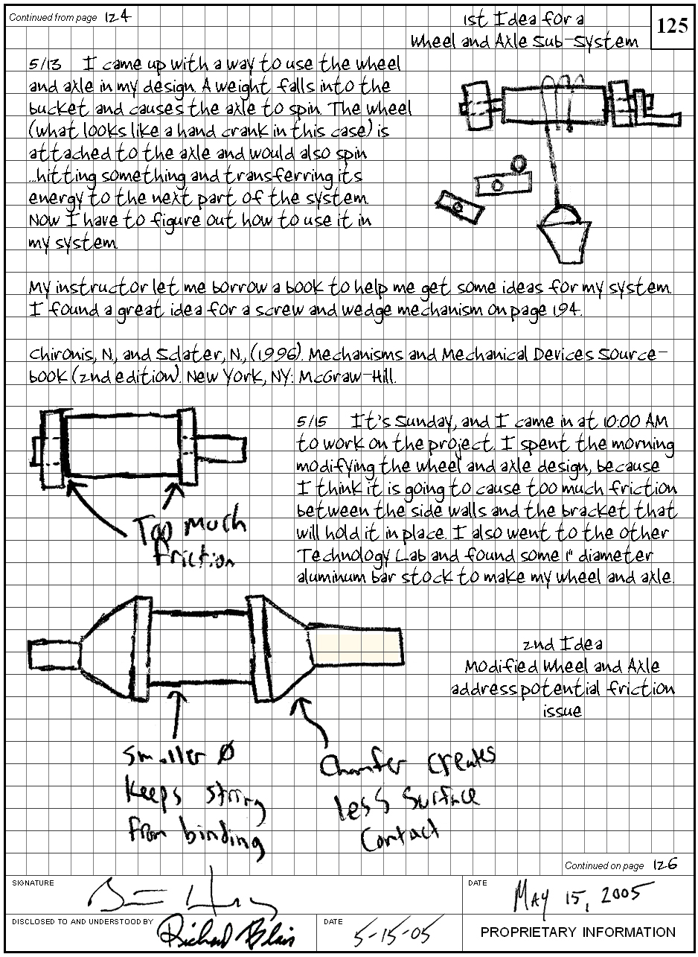

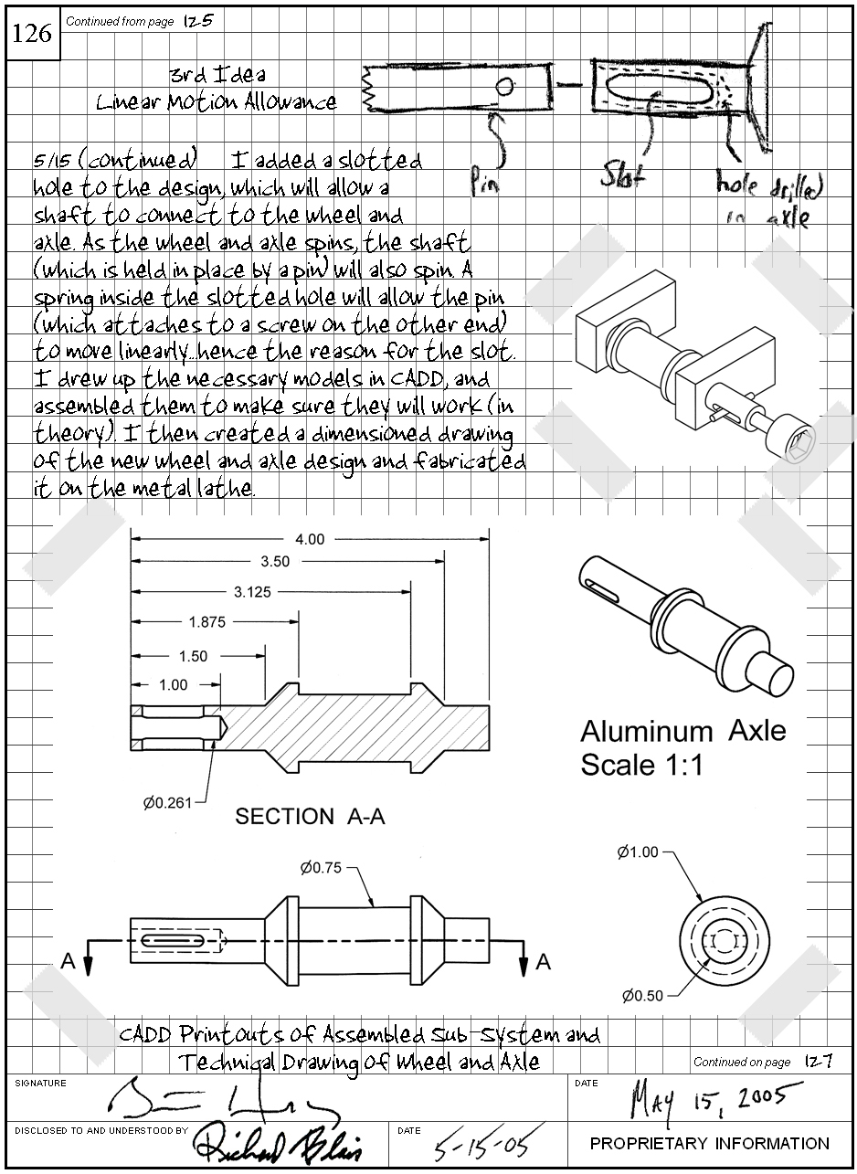

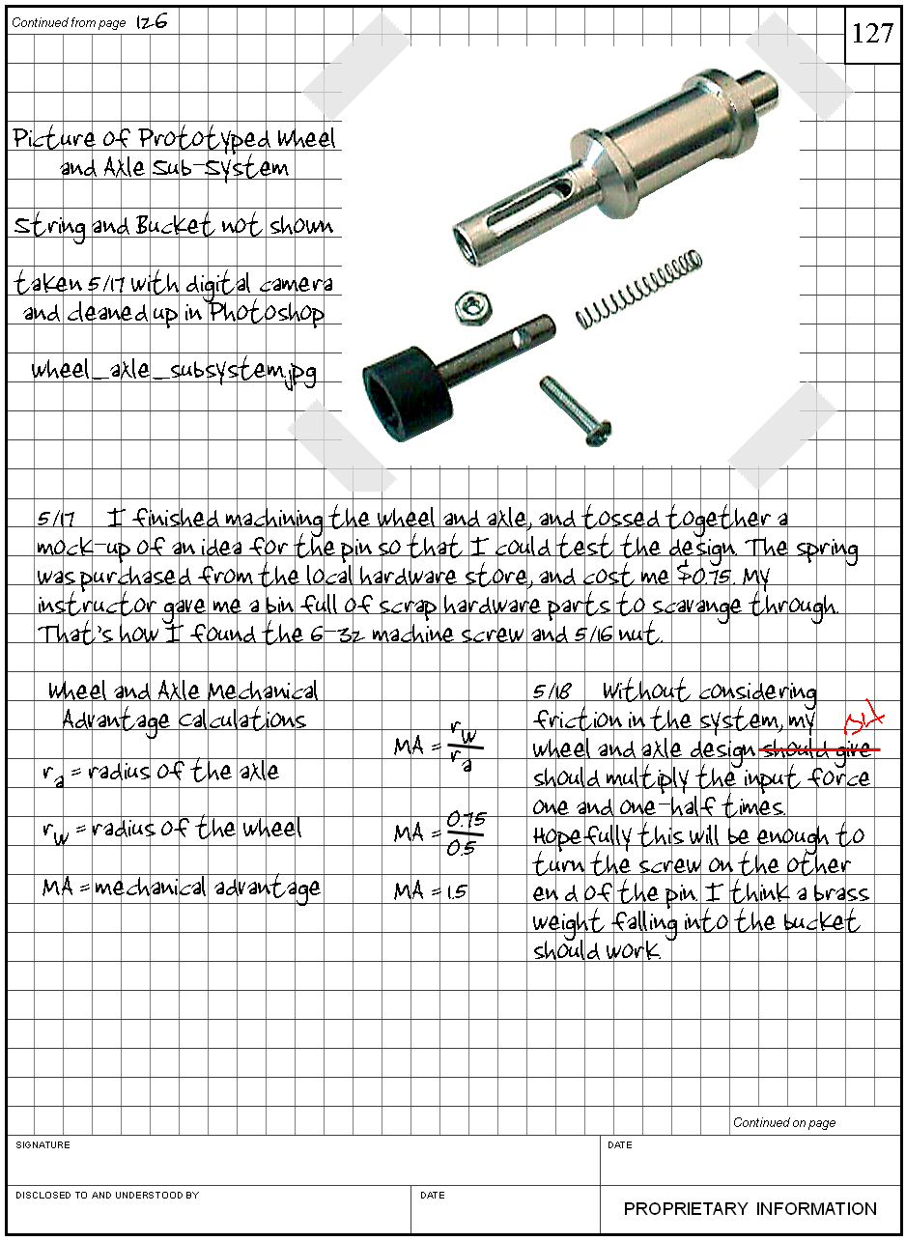

Why did the previous examples represent an excellent engineering notebook?
- The pages have been sequentially numbered.
- The pages are part of a bound notebook.
- There is a dedicated location on each page for the designer’s and witness’s dated signatures.
- All figures and calculations have been clearly labeled.
- Inserted items have been properly attached to their respective pages.
- The date for each entry is clearly identified.
- The student included annotated sketches that help the reader understand the ideas.
- Detailed explanations of how the designs are supposed to work were given.
- The student gave evidence of research.
- Problems that were encountered through experimentation were chronicled, and ideas to fix them were clearly evident.
- A technical drawing for a prototype was given, which specified the material from which the part was to be made.
- A digital photograph of the prototype was included that suggests how the object is to be assembled.
- The information given in the entries is proportional to the amount of time given per class period.
- Any mistakes that were made had a single line drawn through them and were initialed.
The following is an example of an unacceptable engineering notebook. Keep in mind that each entry should represent a reflection of 75 minutes of continuous work.

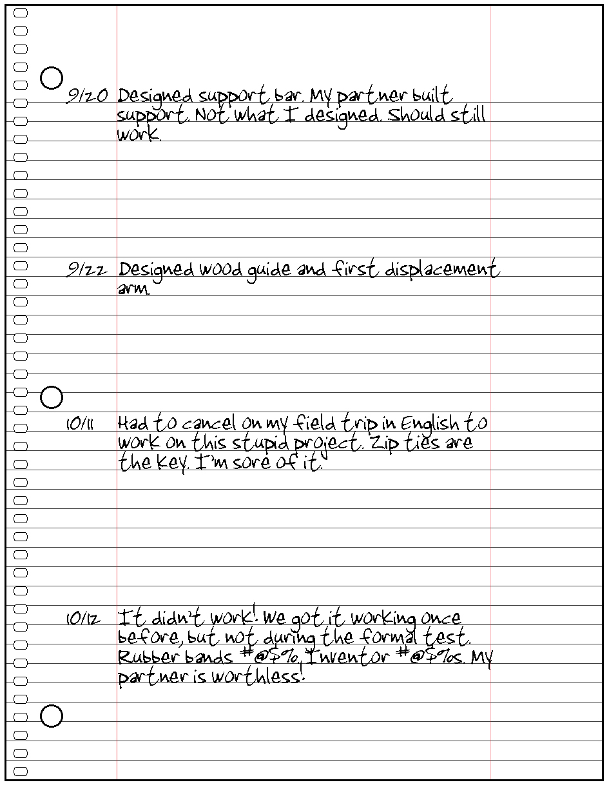

Why did the previous example represent an unacceptable engineering notebook?
- The student submitted a sheet of loose-leaf paper that was removed from a wire-bound spiral notebook. An engineering notebook must be a bound document. No pages should ever be removed from an engineering notebook.
- The page number is not identified in ink.
- The student did not sign and date the page.
- There were several class days between 9/22 and 10/11 that are not represented by notebook entries.
- There were no sketches, CAD model graphics, or technical drawings to support the idea that the support bar, guide, or displacement arm was actually designed or being built. It also appeared that the student was leaving room so that he/she could go back and add sketches later on in an attempt to satisfy the rubric.
- Except for wood, which encompasses a broad spectrum, no tools or materials were identified as being used.
- The student offered no explanation as to functions of the support bar, wood guide, and displacement arm.
- The entries do not show that the partners talked about their ideas or worked on their designs as a team.
- The entries do not talk about any special considerations or problems that might have been encountered during the design of the parts.
- Only fragments of ideas have been documented. There is no detail at all.
- The student used inappropriate expletives in a formal document, and was openly disrespectful to his/her teammate.
- 75 minutes of work cannot be accurately and completely summed up in one sentence.

