Activity 1.7 What Is It?

Introduction
Engineering and design require creativity and the ability to problem solve. You must be able to gather new information, continually learn, and apply what you know to new situations. Engineers try to think outside the box in order to solve new problems or find ways to improve current solutions. In this activity you will act as an engineer and provide an explanation and evaluation of a product that you have hypothetically designed.

Equipment
- Engineering notebook
- Pencil

Procedure
Assume that you are an engineer that has developed a preliminary design for an important problem. Write and present an explanation and evaluation of your design.

- Choose one of the designs represented in the four images presented by your instructor (and reproduced as follows) as YOUR design.
- Think about the object in the image and the problem that it may solve. Answer the following questions.
  - What is it?
  - What problem does it solve?
  - What criteria were used to guide the design?
  - What are the most important features of the design? What features allow it to perform its intended purpose?
  - How does your product affect society and the environment?
- Outline a five paragraph essay that explains your design and answers the questions above. A five-paragraph essay includes an introductory paragraph, a conclusion paragraph, and three paragraphs in the body. Use the format below to outline your essay. You must use at least one of the terms, invention or innovation, within your essay to describe your design.

Five Paragraph Essay Outline Format
Title: ____________________
- Introduction
  - Introductory statement
  - Thesis statement: ____________________

- Body
  - First Supporting Idea (Topic Sentence): ____________________
    - ____________________
    - ____________________
    - ____________________
  - Second Supporting Idea (Topic Sentence): ____________________
    - ____________________
    - ____________________
    - ____________________
  - Third Supporting Idea (Topic Sentence): ____________________
    - ____________________
    - ____________________
    - ____________________

- Conclusion
  - Closing statement
  - Restate thesis: ____________________
About the Author (sixth paragraph)
The thesis statement should identify the object or design and describe the problem that the design solves, that is, the purpose of the design. The body paragraphs should provide support for your thesis statement by describing three features of the design and discussing how each feature helps solve the problem.

- Using the outline you have created, write a five-paragraph essay that explains your design, the problem it solves, and its most important features.
- Add a paragraph entitled About the Author to the end of your essay. In this additional paragraph, describe your discipline of engineering and how knowledge from that discipline helped you create your design and solve the problem.
- Review and evaluate a classmate’s essay using the Activity 1.7 What Is It? Essay Rubric.
- Present a one minute elevator pitch to your class describing your design, the problem it solves, and its most important features. An elevator pitch is an expression describing a short presentation with the goal to communicate major ideas and generate interest in your subject. The length of the presentation should short enough to be completed in a typical elevator ride.
Conclusion Questions
- Why is it important for engineers to be creative and think outside the box?

- What other characteristics do you believe engineers should possess in order to be successful problem solvers?

Design Images:

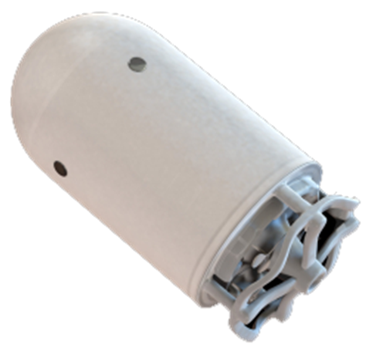 | 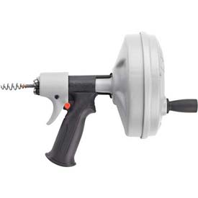
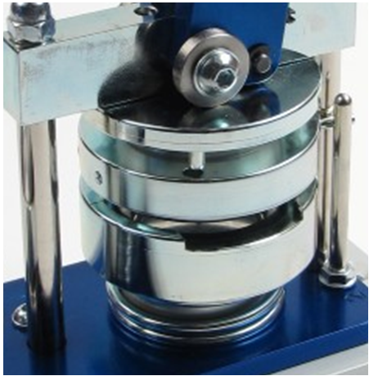 | 