Activity 1.2.4 Circuit Theory – Breadboarding

Introduction
Breadboarding is an essential skill for anyone who plans to design analog and/or digital circuits.
In this activity you will gain experience using a breadboard to build and test simple analog circuits. In future activities we will breadboard digital circuits as well.
The circuits analyzed in this activity are some of the same circuits that were analyzed by hand in Activity 1.2.2 and simulated in Activity 1.2.3. This will allow you to compare the theoretical, simulated, and measured values.
Equipment
- Paper and pencil
- Digital Logic Board (DLB)
- Digital Multimeter (DMM)
- Jumper wire
- Discrete components (resistors)
- Variable power supply

Procedure
- Using a Digital Logic Board (DLB) and variable power supply, construct the circuit shown below. Use a digital multimeter (DMM) to measure I_{T}, V_{R1}, V_{R2}, & V_{R3}.

Remember, unlike measuring voltage, the current measurement is an intrusive measurement. This means that you must temporarily modify the circuit. Redirect the current through the DMM and then direct it back to the circuit.

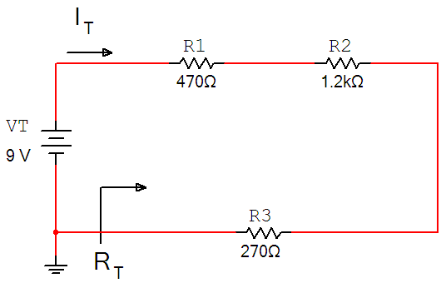

In this activity you will alternately measure voltage and current with the same DMM.
Be sure that the meter is in the proper mode for what is being measured before the power is applied.

This circuit was analyzed by hand in Activity 1.2.2 and simulated in Activity 1.2.3.
How do these measured values compare to the previously calculated and simulated values? If they do not match, review your circuit, your calculations, and make any necessary corrections.

- Using a Digital Logic Board (DLB) and variable power supply, construct the circuit shown below. Use a digital multimeter (DMM) to measure I_{T}, V_{R1}, V_{R2}, V_{R3,} & V_{R4}.

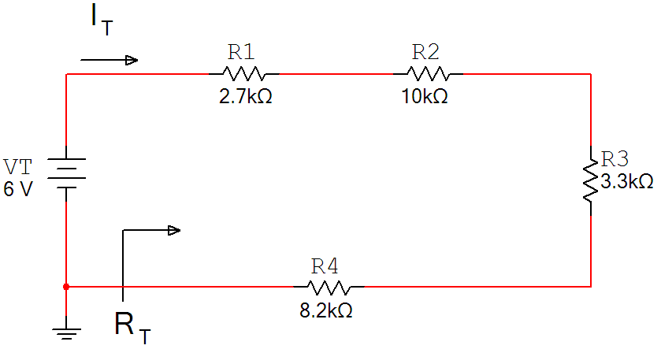
- Using a Digital Logic Board (DLB) and variable power supply, construct the circuit shown below. Use a digital multimeter (DMM) to measure I_{T}, I_{R1}, I_{R2}, & I_{R3}.

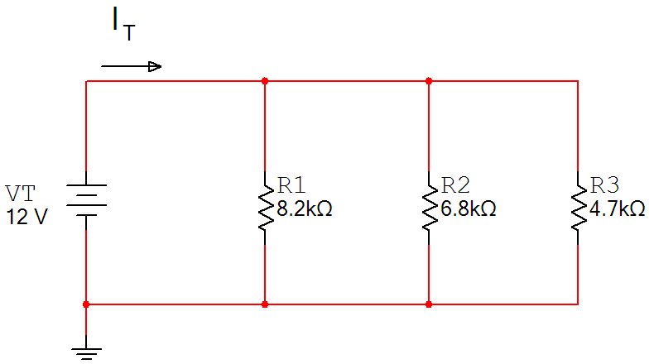
- Using a Digital Logic Board (DLB) and variable power supply, construct the circuit shown below. Use a digital multimeter (DMM) to measure I_{T}, I_{R1}, I_{R2}, I_{R3,} & I_{R4}.

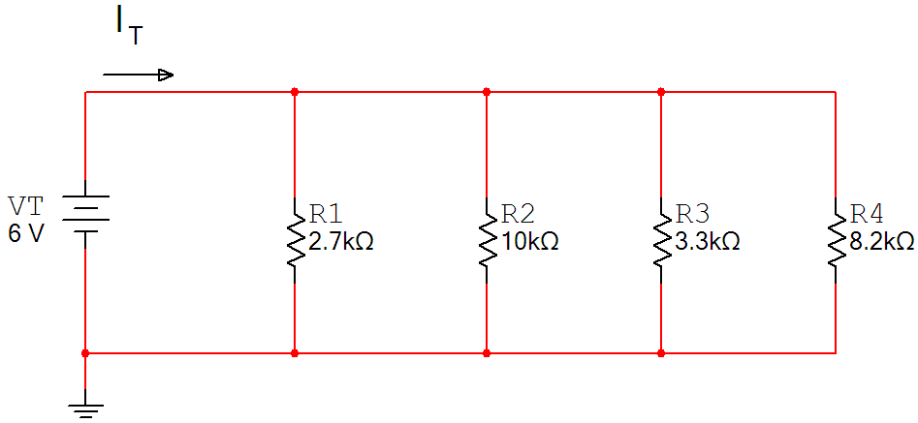
Conclusion
- You have now analyzed the same circuits three times;
  - by hand in Activity 1.2.2
  - via simulation in Activity 1.2.3
  - via breadboarding in this activity
How did these values compare and what might account for any differences?

- How does the technique for measuring current with a DMM differ from measuring voltage?

- What is the origin of the name “breadboard”?

