Activity 1.2.6 The 555 Timer

Introduction
The 555 Timer oscillator is one of the most common circuits used in introductory electronics. It is a favorite among beginners because of its low cost and ease of design. These are precisely the same reasons the 555 Timer is used in the Board Game Counter design.
In this activity you will simulate and build a 555 Timer oscillator. You will observe the effect that varying the value of its resistor and capacitor values has on the oscillation frequency and duty cycle.
Equipment
- Paper & pencil
- Circuit Design Software (CDS)
- Digital Logic Board (DLB)

Procedure
- For the 555 Timer oscillator circuit shown below, calculate the frequency and duty cycle of the output signal based on the component values shown.

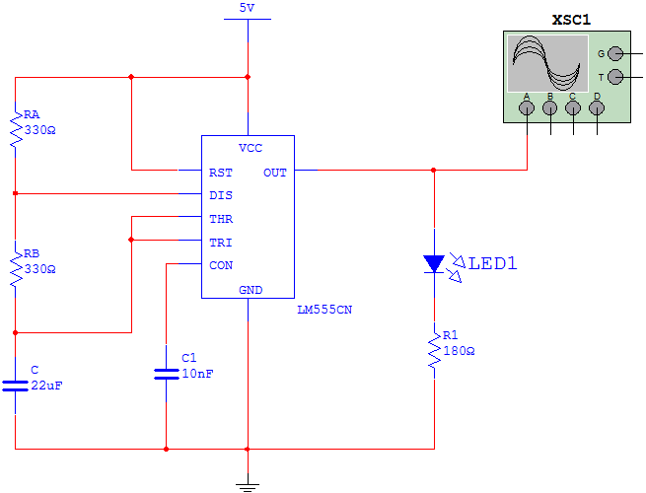
- Use the CDS to enter and simulate the 555 Timer oscillator circuit.
Use the oscilloscope’s markers to make the necessary measurements.
Determine the frequency and duty cycle of the output signal.
How do these values compare to the calculated values?

- Repeat steps (1) and (2) for each set of component values in the table shown below. Note that the shaded areas are the values that were measured from the original circuit.
RA | RB | C | Period(T) | Frequency(f) | t_{H} | t_{L} | Duty Cycle
100 Ω | 330 Ω | 22 μf
330 Ω | 330 Ω | 22 μf
560 Ω | 330 Ω | 22 μf
330 Ω | 100 Ω | 22 μf
330 Ω | 330 Ω | 22 μf
330 Ω | 560 Ω | 22 μf
330 Ω | 330 Ω | 10 μf
330 Ω | 330 Ω | 22 μf
330 Ω | 330 Ω | 47 μf

Conclusion
- Review the results of the data collected in step (3) of the procedure.
- What effect did varying the RA have on the frequency and duty cycle?

- What effect did varying the RB have on the frequency and duty cycle?

- What effect did varying the C have on the frequency and duty cycle?

