Activity 5.1 Calculating Properties of Shapes

Introduction
If you were given the responsibility of painting a room, how would you know how much paint to purchase for the job? If you were told to purchase enough carpet to cover all the bedroom floors in your home, how would you communicate the amount of carpet needed to the salesperson? If you had to place an order for new shingles for the roof of your home, how would you determine the number of shingles needed? Aside from the fact that each of these questions deals with home improvement issues, they all center on the concept of area.

Area describes the measure of a two-dimensional surface. One example of how area is used in engineering is the calculation of stress that develops in an object that is subjected to an external load. If you have ever stretched a rubber band to the point that it breaks, then you have applied an external load to an object that has a constant cross-sectional area. In doing so, you caused stress to build up inside the rubber band until it broke. Another example of how area is used in engineering is the calculation of beam deflection. If you have ever walked across a fallen tree in an effort to cross a creek, then you have experienced the concept of deflection. If the tree had a small diameter, then the amount of deflection would be significant and noticeable. If the tree had a large trunk, then the amount of deflection was probably too small to feel or notice.

Equipment
- Engineering notebook
- Pencil
- Calculator
Procedure
In this activity you will broaden your knowledge of shapes and your ability to sketch them. You will also learn how to calculate the dimensions and area of a shape. Use points, construction lines, and object lines to sketch the shapes described in the first seven word problems. Use the notes contained in your engineering notebook to help you perform the necessary calculations. Calculator use is encouraged, but you must show all of your work.

- Use the sketch below to calculate the area of the square. Add all linear dimensions to the sketch that were used in the calculations. Note: each grid unit = 1 inch.
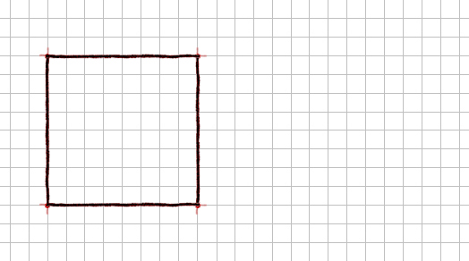

- The area of the square represented above is revised to be 90.25 in.². Note that the original grid spacing no longer applies.
  - What is the side length of the square? Justify your answer.

  - Using this length, what would be the corresponding grid spacing for the sketch above? Justify your answer.

  - What size circle would you cut out of the square in order to have a remaining area of 66.5 in²? Justify your answer.

  - Apply all necessary annotations and dimensions to size the shapes and locate the circle in the center of the square.

- Complete the sketch of the rectangle. It must have an area of 2.25 in.² Prove the enclosed area by dimensioning the sketch and showing the area calculation. Show only those dimensions needed for the area calculation. Note: each grid unit = 0.25 inch.

- Use the sketch below to calculate the area of the rhomboid. Add linear dimensions to the sketch that were used in the area calculation. Note: each grid unit = 1 inch.
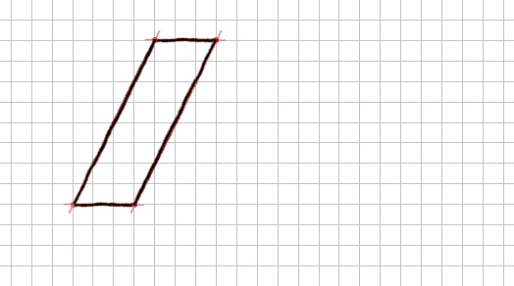
- Complete the sketch of the obtuse triangle. It must have an area of 1.75 in.². Prove the geometry by dimensioning the sketch and showing the area calculation. Show only those dimensions needed for the area calculation. Note: each grid unit = .25 inch.
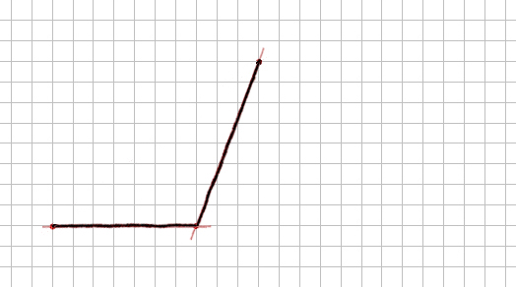

- You are given a sheet of cardboard that is 8.5 in. x 11 in. What is the maximum number of full circles with an area of 7.1 in.² each that can be cut from the sheet?

- An ellipse has an area of 4.71 in.² and a minor axis that is 2 in. long. Solve for the major axis, and then sketch the ellipse using that dimension. Show only those dimensions needed for the area calculation. Note: each grid unit = .25 inch.
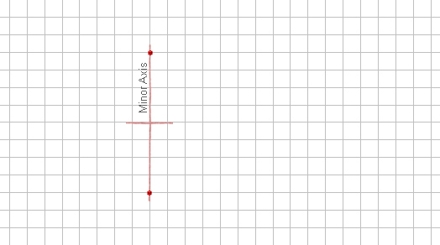

- What side length would you specify if you were required to create a regular hexagonal plate that was comprised of 33.0 cm² of sheet metal? Sketch the hexagon, dimension the side length on the sketch to 0.1 cm, and indicate your grid spacing. Justify your dimension.

Extend Your Learning
- The sketch shown below is for a commercial sign. It was drawn to 1/10 of its true size. What is the area of the actual sign? Prove your answer by showing all calculations. Note that the sign was not drawn to scale but was drawn on a grid in which the grid spacing unit is 1 inch.
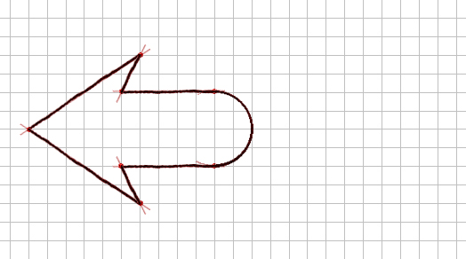

More Challenging
- A standard stop sign measures 30 inches from flat to flat. What is the side length, x, of the stop sign (to the nearest 0.01 in.)? Justify your answer.
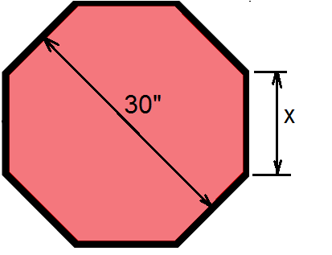

Conclusion
- What is the difference between a circle and an ellipse?

- What is the difference between an inscribed and a circumscribed shape?

- Why is it impossible for a triangle to contain a 180° angle?

- How is a rhombus similar to a square?

- What is the difference between a right, acute, and obtuse triangle?

