Unit 5 Automoblox T9 Dimensioned Drawings

The following drawings are provided for information only to be used with Activity 5.2 Making Sketches in CAD and Activity 5.5 CAD Model Features and are not intended to provide complete details. Only partial dimensions for some of the T9 Automoblox model components are given in order to provide the measurements necessary to complete Activities 5.2 and 5.5 when the physical models are not available.

PASSENGER BASE
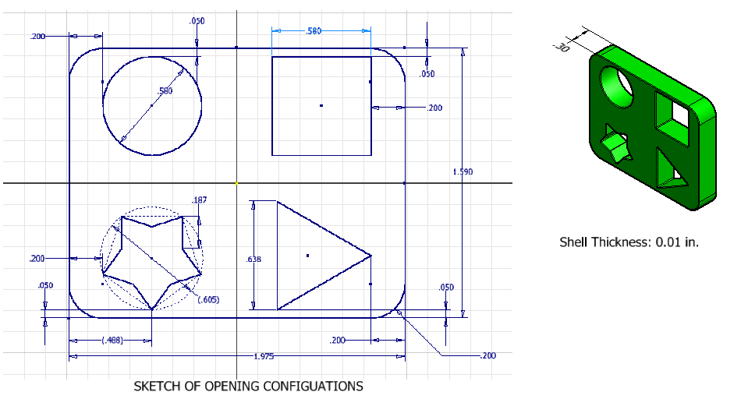

PASSENGER SECTION
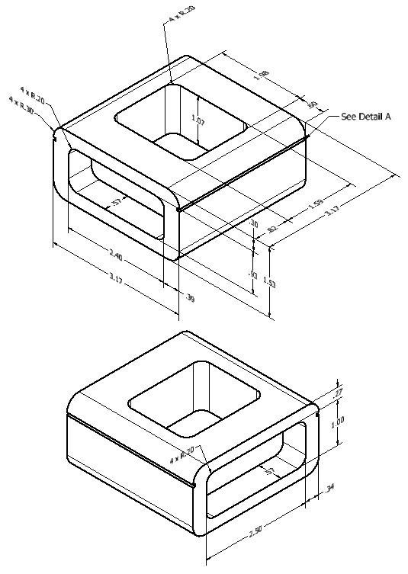 | 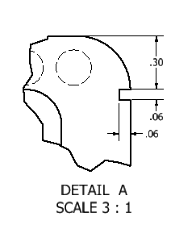

WINDSHIELD
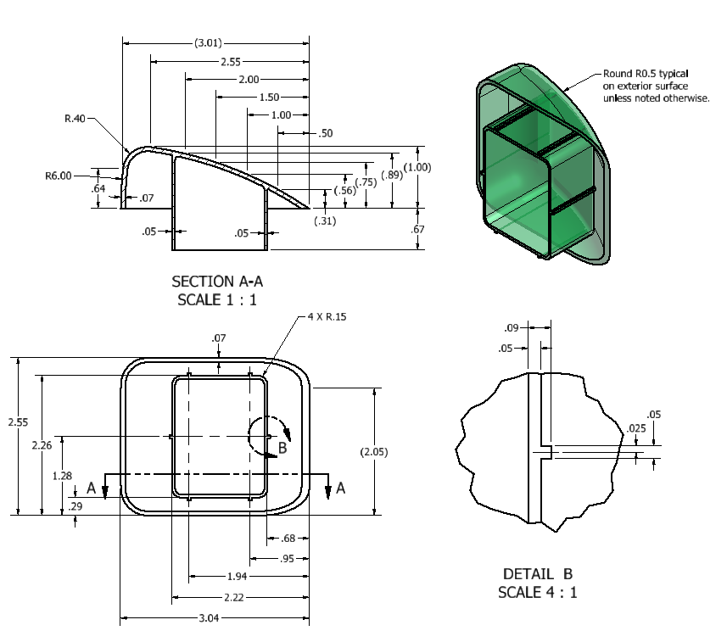

AXLE

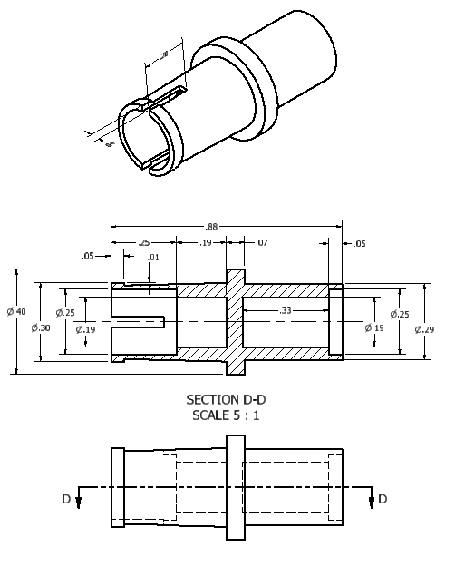

Conclusion

- What advantages do CAD sketches have over freehand sketches?

- What disadvantages do CAD sketches have when compared to freehand sketches?

- What types of numeric constraints may be applied to sketches?
- Explain the difference between the Fillet sketch tool and the Fillet placed feature.

- The Fillet placed feature is used to create both a “fillet” and a “round”. Describe the difference between the two results.

- Could the Shell feature be used to create the opening in the Automoblox body passenger section? Explain your answer.

