Activity 5.2b Introduction to CAD Modeling Skills

Introduction
The capability of computers and software is astounding in some respects. For instance, computers can generate a solid computer model using a 3D scanner to analyze an existing object or space. Likewise, internal body organs and tissue can be “seen” using technology such as Magnetic Resonance Imaging (MRI). Unfortunately, commercially available computer systems have not advanced to the extent that they can document ideas and mental images from the human brain. For now engineers must continue to express ideas as sketches – hand drawn and computer generated.

A CAD model can quickly display an engineer’s ideas in a realistic way. And once an engineer has developed a model in CAD representing an idea, the idea can be shared much more easily with a wider audience. As is the case with technical sketching, CAD models must begin as sketches of points, lines, and shapes. However, a computer model can be much more accurate and precise than a freehand sketch. The lines of a CAD sketch can be drawn perfectly straight (or perfectly circular), with start and end points that occur in exact locations in space. A line may also be given precise length through the use of dimensions. If more than one line is being sketched, they can be made perfectly parallel or perpendicular or shown at a precise angle. CAD programs give designers the ability to sketch any kind of geometry and provide the ability to dimension, extend, rotate, mirror, copy and paste, pattern, move, and trim (to name a few tools) that geometry. Whereas hand-drawn representations are made to appear three dimensional by the strategic placement of additional points, lines, and shapes, CAD sketches can be transformed into 3D models using features that appear to add and manipulate material. As a result, within the software designers can extrude, revolve, or sweep a sketch such that the two dimensional sketch appears to become a solid form that can be electronically manipulated and viewed from any angle. Once a 3D model is created, the solid form can be hollowed out or the edges can be rounded.

The ability to realize CAD models through sequentially developing geometric sketches and generating 3D forms is a critical skill that designers in multiple engineering disciplines use in the process of converting mental images into money-making products. In order to effectively use a CAD program as a design tool, a designer must be familiar with the use of the available tools and features within the software. This activity will help you to understand and utilize the most frequently used sketching and feature tools that are common to most CAD programs.

Equipment
- Computer with 3D CAD solid modeling program
- Dimensioned sketches of measured Mini Train Project Parts
Procedure
The exercises contained in this activity require the creation of new CAD files in which you will reproduce sketches and forms represented in the displayed mages. . Most of the CAD files created in this activity will be Mini Train Project part files.

Before beginning this activity, create an electronic Mini Train Project folder in which you will save all files associated with your Mini Train Project. Create a second electronic folder entitled Practice to store non- Mini Train Project part files. As you finish each exercise, save the associated CAD file in the appropriate folder. It is important that all Mini Train Project parts be saved to a single project folder for later use.

Sketch Tools – These are suggested tools for this activity
- Rectangle Tool
- Fillet
- General Dimensioning (Numeric Constraints) Size and Location
- Adding new sketches to same part
- Text

Feature Tools – These are suggested tools for this activity
- Extrude (Add/join and Cut)
- Emboss
- Emboss
- Properties (Face Appearance)

- Reproduce the sketch below for the Mini Train Project Linkage Arm. Save the file as LinkageArmYourIntitials.ipt in your Mini Train Project Folder
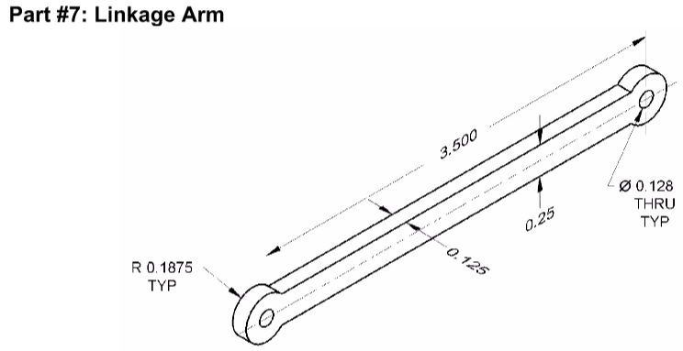

Text and Emboss
- Emboss your name on the 3D model that you just created.
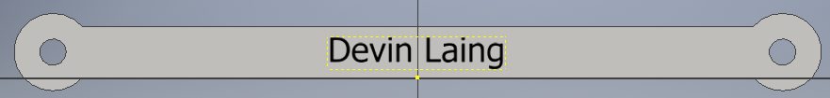  1. Create a sketch and use the Text tool to write your name. Place the sketch in the middle of your linkage arm | 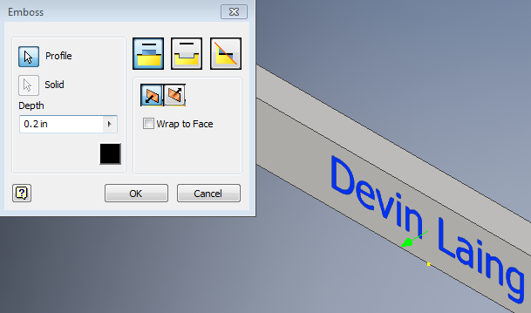  2. Use the Emboss features to create raised letters. Use a depth of 0.02 inches.
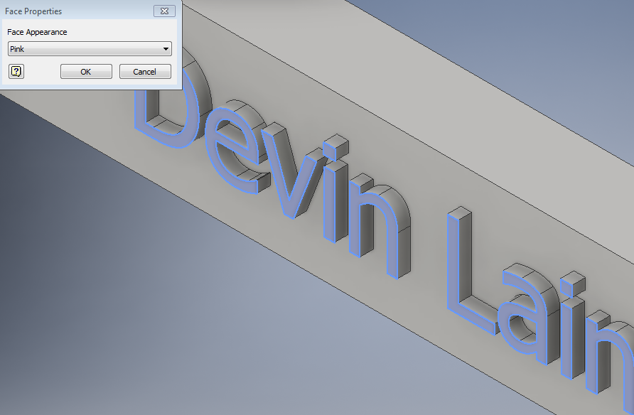  3. “Paint” the surface of the embossed letters by changing the face color style of the surface. Select the surfaces of the letters, right click, select Properties, and then choose an option from the list of colors. | 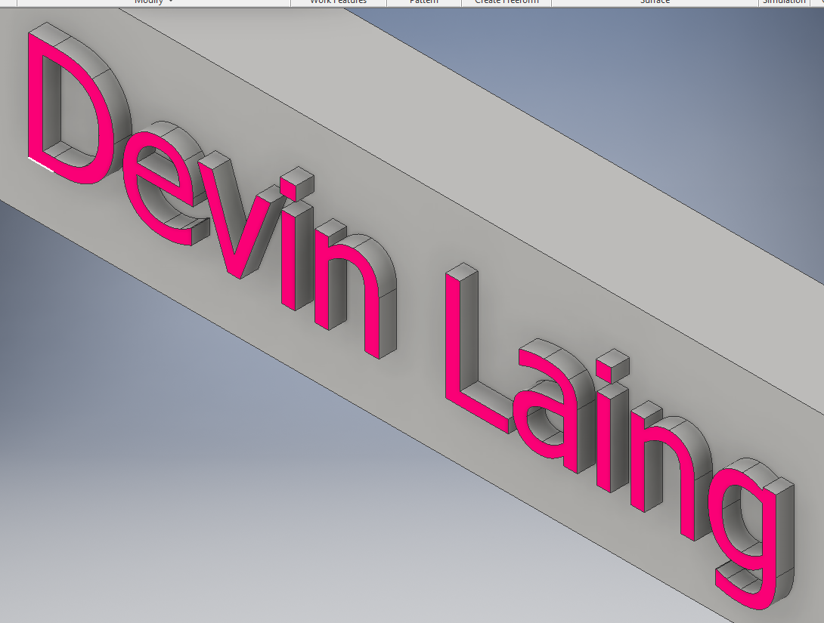  4. Finished letters. Save the file.

Mini Train Project – Cow Catcher

- Begin to create a 3D solid model of the cow catcher of the Mini Train. See Tutorial Video for assistance.
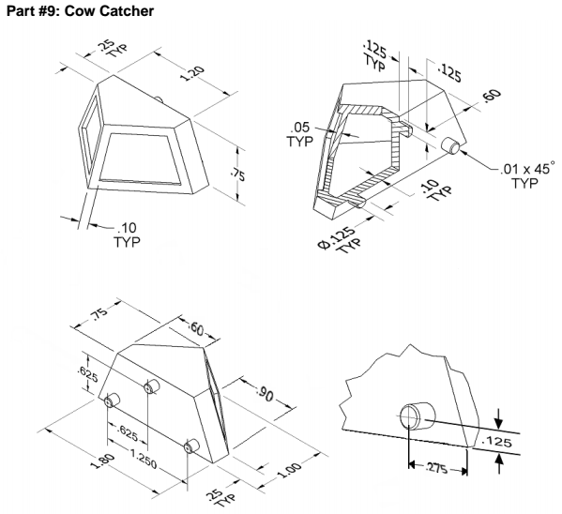

Chamfer

- Generate a structural angle part as described below.

- Reproduce the sketch shown below. Apply the dimensions and constraints as shown in the image and then extrude the sketch to a depth of 1.5 inches.

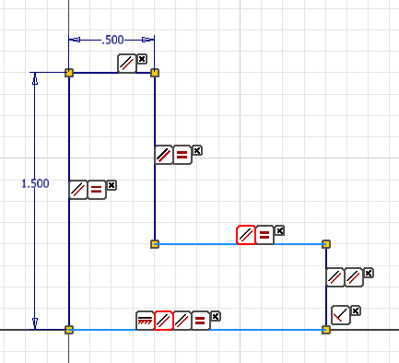

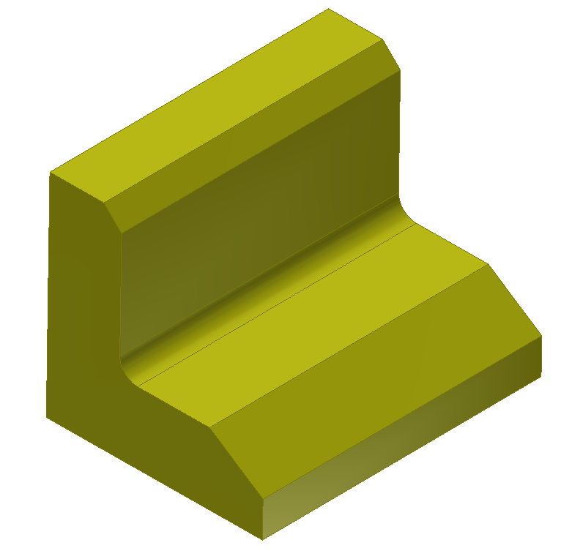
- Activate the Chamfer tool in the Modify panel. On the top outside edge, apply a 45 degree chamfer with a distance of 0.125 inches.
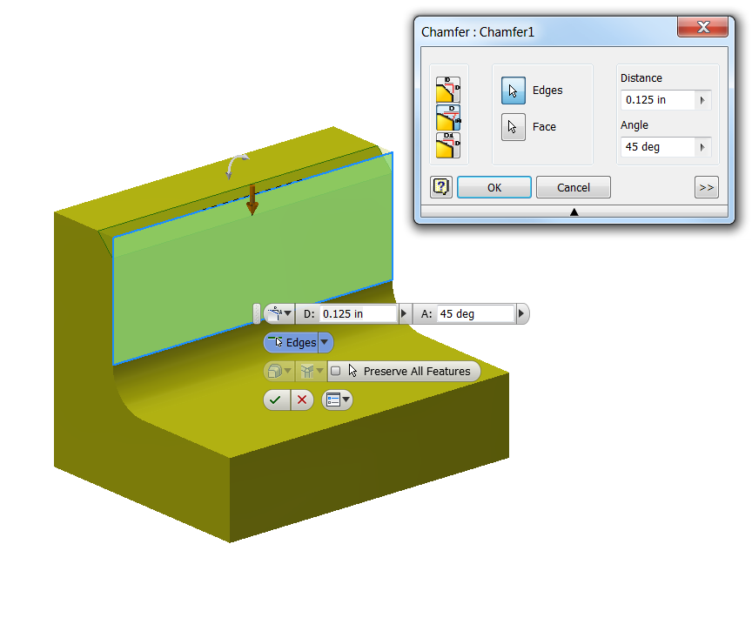
- In a similar manner, apply a chamfer with two different distances – 0.25 inches vertically and 0.375 inches horizontally.
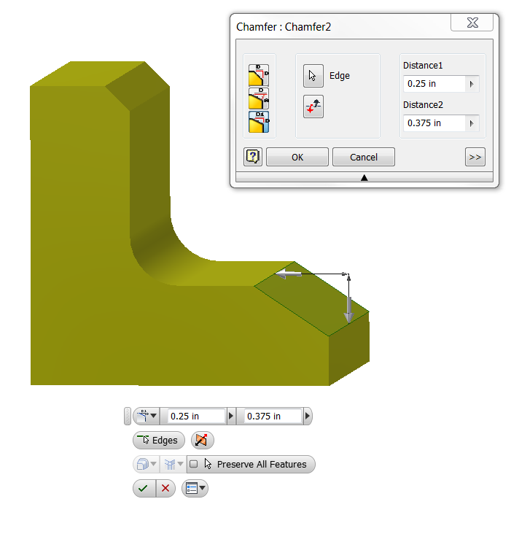
- Next, add a fillet of radius 0.125 on the insider corner.
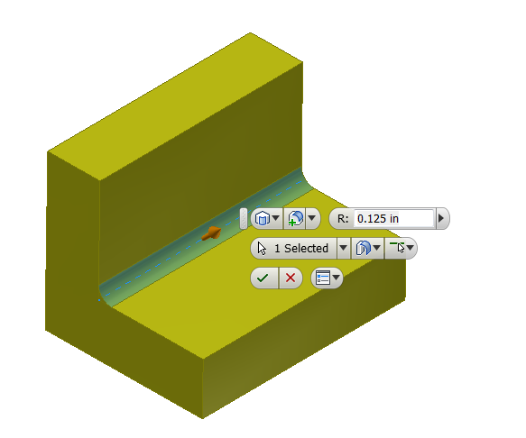

- Save the file.

Mini Train Project Wheel (Simplified Version)
Note: This model will not replicate the Automoblox wheel exactly. Once you have gained more familiarity with 3D solid modeling tools and features, you may want to try to more closely mimic the contours of the wheel. Suggested steps to creating a basic wheel form are given below. There will be an opportunity for you to redesign the Automoblox wheel in Unit 8.

Sketch Tools – These are suggested tools for this activity
- Circle
- Offset
- Geometric Constraints (Manually placed/auto-placement)
- General Dimensioning (Numeric Constraints) Size and Location
- New Sketch (2D)
- Project Geometry
- Trim / Extend
- Circular Pattern

Feature Tools – These are suggested tools for this activity
- Extrude (Add / Cut)

X. Create a 3D model of the wheel for the Mini Train. See Tutorial Video for assistance.

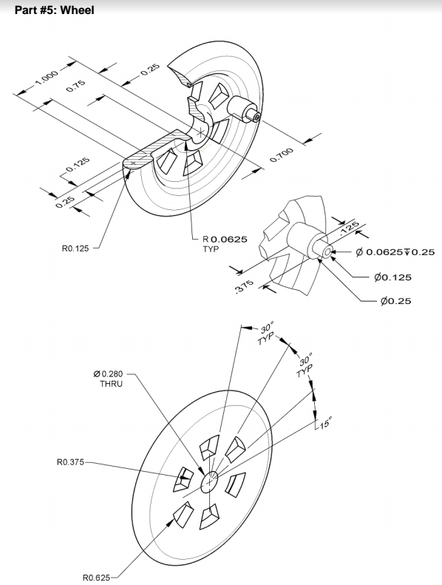

- Save the file as WheelYourInitials.ipt.

Conclusion

- What advantages do CAD sketches have over freehand sketches?

- What disadvantages do CAD sketches have when compared to freehand sketches?

- What types of numeric constraints may be applied to sketches?

