Unit 1.1: Mechanisms
- Define Unit 1.1 Vocabulary
Key Term | Definition

- Know the six simple machines, their attributes, and components.
  - Lever

  - Wheel and Axel

  - Pulley

  - Inclined Place

  - Wedge

  - Screw

- Know the equations to solve for mechanical advantage, work, and power.

  - Mechanical Advantage

  - Work

  - Power

- Know the machines created with gears, pulleys, and sprockets, their attributes, and components.
  - Gears

  - Pulleys

  - Sprockets

  - Belts

  - Chains

- Understand how to determine efficiency in a mechanical system.

- Understand how to design, create, test, and evaluate a compound machine designs.

Unit 1.2: Energy Sources
- Define Unit 1.2 Vocabulary
Key Term | Definition

- Describe the characteristics of various sources of energy.
  - Coal

  - Oil

  - Natural gas

  - Nuclear

  - Solar

  - Biomass

  - Hydroelectric

  - Geothermal

  - Wind

  - Other

- Know types of nonrenewable, renewable, and inexhaustible energy sources.

- Know the equations for work and power.

- Know the equation for calculation the efficiency of a system

- Know the equations related to describing the characteristics of simple circuits

  - Ohms Law

  - Kirchhoff’s Voltage Law

  - Kirchhoffs Current Law

- Compare and contrast the behaviors of series and parallel circuit designs
  - Parallel Circuits

  - Series Circuits

- Understand the tools used to design, build, evaluate and test simple circuits?

  - Multimeters

  - Breadboards

  - Schematics

  - Components

Unit 1.3: Energy Application
- Define Unit 1.3 Vocabulary
Key Terms | Definition

- Explain how Energy systems can include multiple energy sources that can be combined to convert energy into useful forms:

- Compare and contrast convection, conduction, and radiation as processes for transferring thermal energy, and will describe each process.
  - Convection

  - Conduction

  - Radiation

- Using a R-value chart and the illustration below to calculate the R-value of the wall cavity and the R-value at the stud location.

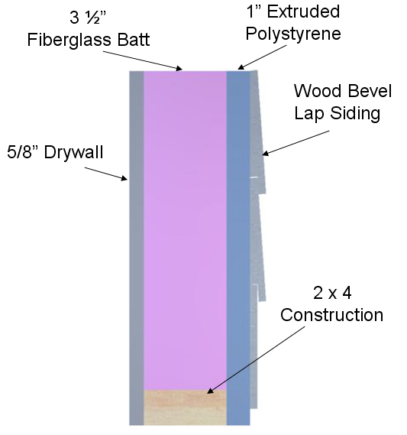

- Solve: A 1.00 kg piece of aluminum metal at 90.0 °C is placed in 4.00 liters (= 4.00 kg) of water at 25.0 °C. Determine the final temperature (T_{f}).
  - List all known values
  - List all unknown values
  - Select Equations
  - Apply known values
  - Solve

- Define Stefan’s Law.

- Understand the flow of heat energy in a system is related to material properties and system design, and by considering the thermodynamics of a system, an engineer can predict and manipulate the amount of energy transferred.

- Find an example of a thermodynamics problem that requires the use of combined equations to find the desired solution. For example, an unknown variable in one equation is satisfied though the use of a second, different equation

